**Cinema Management System**

**|V-Flex |**

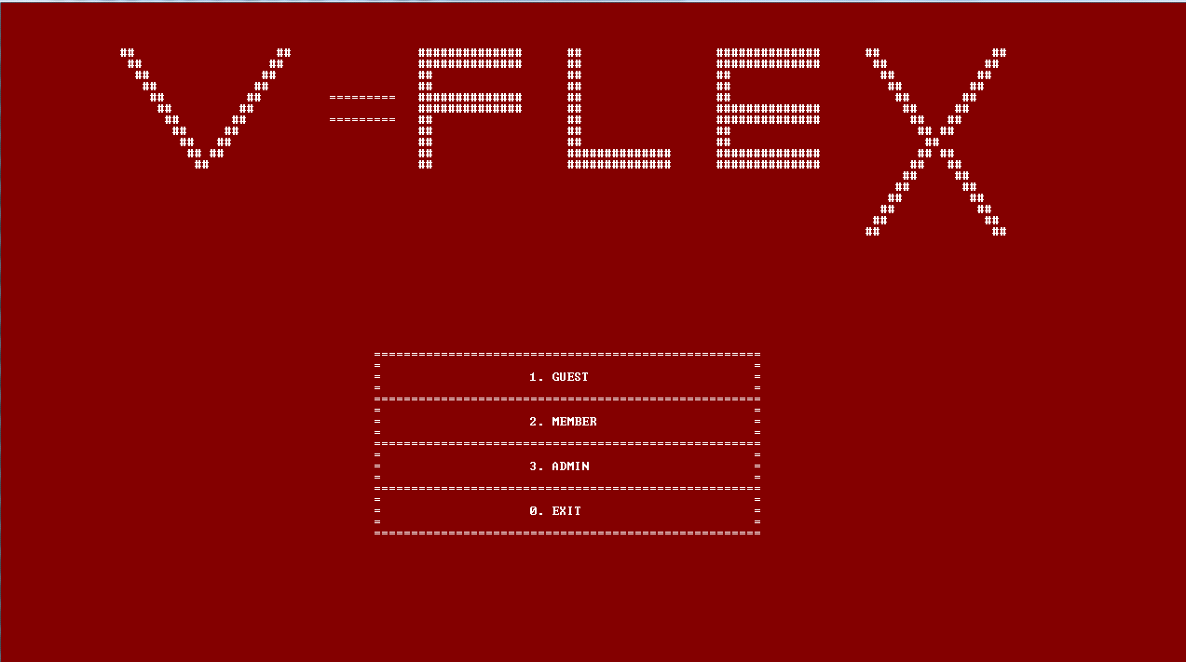

**Made by:**

**----> Mustafa Mirza**

**----> Anfaal Ahmed Khan**

**----> Unais Yousha Siddqui**

**2. Abstract:**

**The aim of making this project was to make a interface which can make the work easier for the Cinema management team and for the customer who is using it. It gives admin option to add movies and its different screens along with the timings. The guests can check the available movies in the cinema and can register in the available seat slots. There is a special option for registering as member, the members can avail a discount on purchasing seats. Overall, our project tries to make a user friendly interface so no one face any problem while using it.**

**3. Introduction:**

**The project is made in a way that anyone can use it without facing any trouble. The backend of the project is made on C++. It has modules for Admin, guest and members. Member module will ask the user to input their name and a 4-digit pin to register.Then it will show a screen where they can choose movie and its tickets. This module is for the people who want to be our members. This is paid.The advantage of becoming a member is that they can avail a special discount on booking a seat. Guest interface works in the same way, but it will directly head towards the movie selection phase.**

**-> Modules:**

**1.Admin**

**2.Guest**

**3.Member**

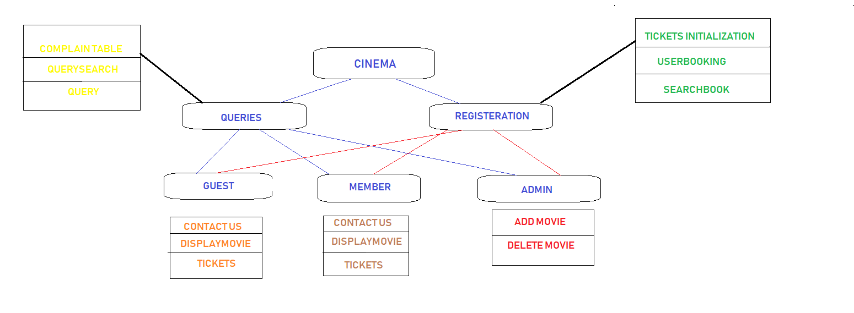

**5. Libraries:**

**1 -> Iostream**

**2 -> String.h**

**3 -> String**

**4 -> Fstream**

**5 -> conio.h**

**6 -> stdlib.h**

**7 -> windows.h**

**8 -> bits/stdc++.h**

**6. Project Snapshots:**

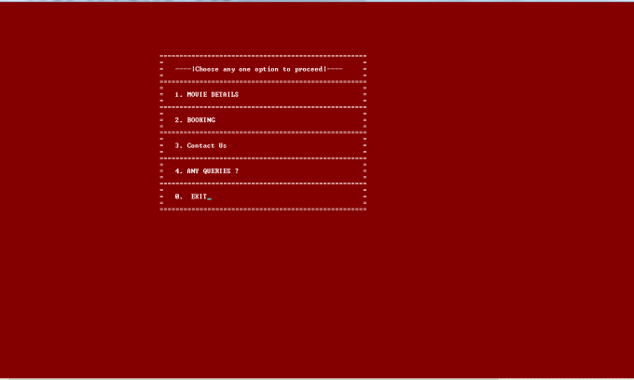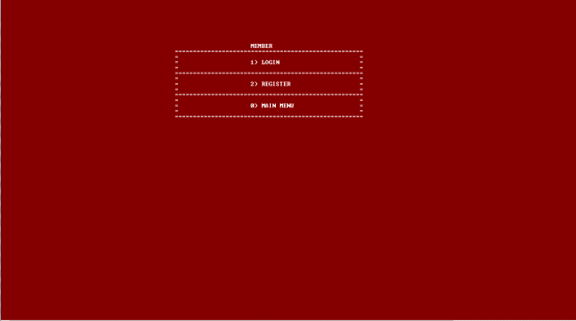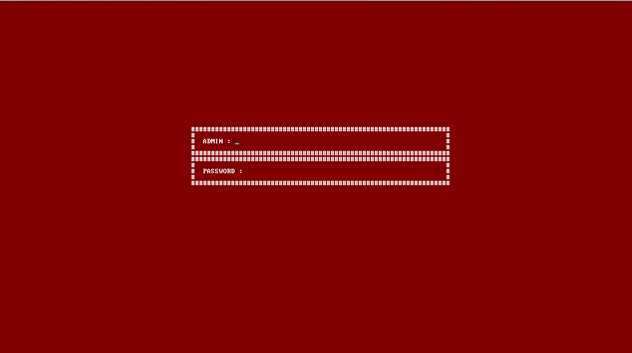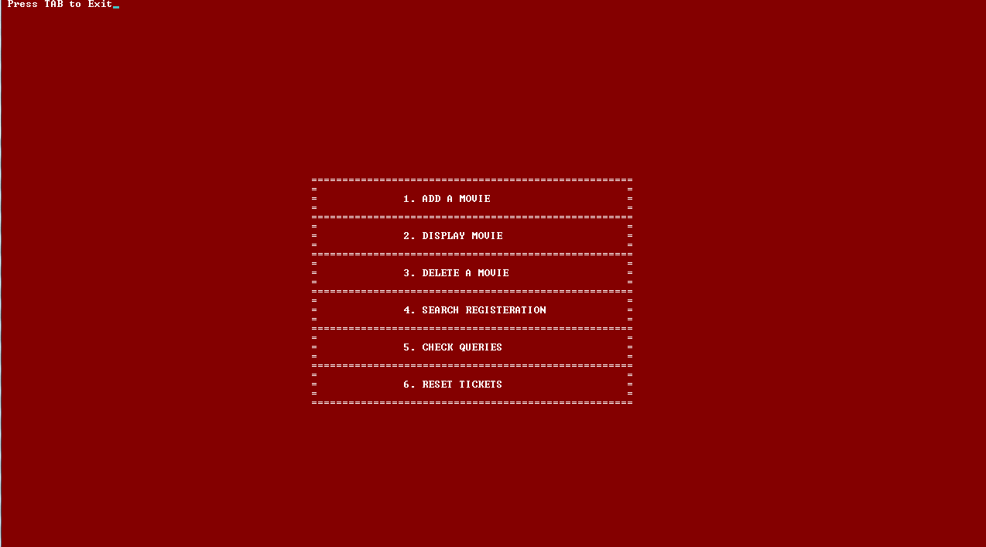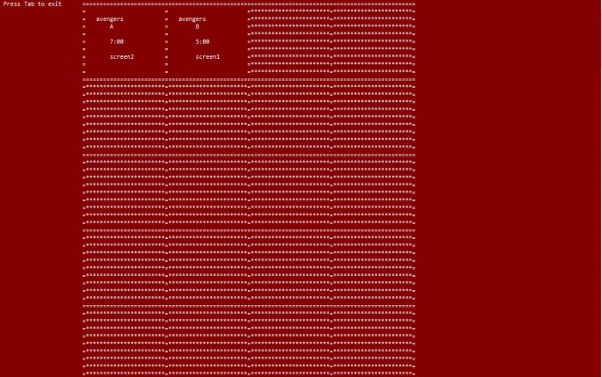

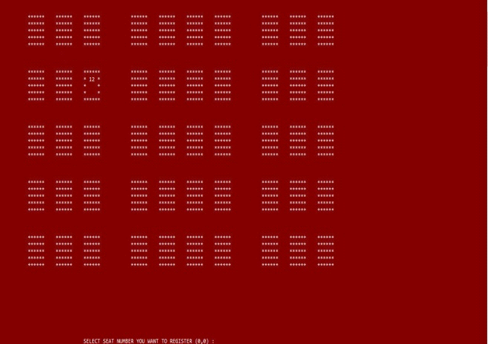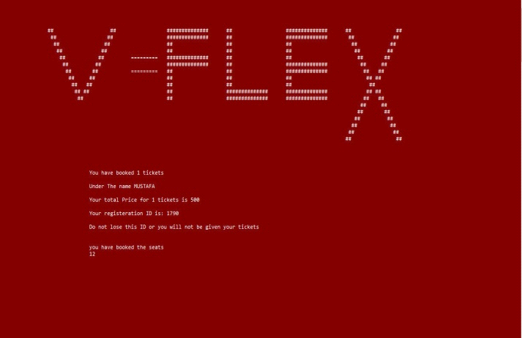

**7. Group members particiaption:**

**-> Mustafa Mirza worked on the Admin class.**

**-> Anfaal Ahmed Khan worked on the Guest class.**

**-> Unais Yousha Siddiqui worked on the Member class.**

**If we talk about the whole project, we all did contribution in eachother's work.**

**8. Conclusion:**

**The system is highly secured. The information of added by the Admin can not be accessed by anyone. Member details are kept secured ,too Our project guarantees to run fast without consuming much of your random access memory. Our system will enhance your experience.**

**9. Future Work:**

**We have decided to release monthly updates to make this application even better than ever. Many other features will be added soon.**

**9. References:**

**1 -> GeeksForGeeks.org**

**2 -> Stackoverflow.com**

**3 -> Tutorialspoint.com**